BARNS GREEN VILLAGE HALL
MUNTHAM DRIVE
BARNS GREEN
RH13 0PT
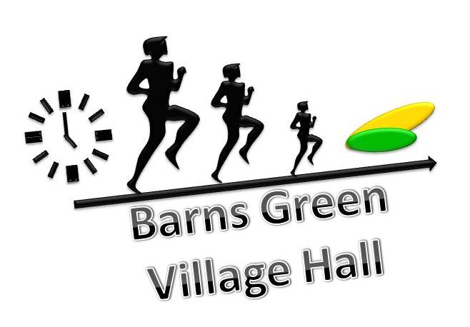

Booking Form
CONTACT DETAILS
NAME:
ADDRESS:
TELEPHONE:
EMAIL:
PERSON RESPONSIBLE DURING HIRE PERIOD
(IF DIFFERENT FROM ABOVE)
ADDRESS:
TELEPHONE:
EMAIL:
BOOKING DETAILS
DATE:
TIMES (MUST INCLUDE SET-UP/CLEAR-UP TIME):
EXPECTED NUMBER OF PEOPLE AT EVENT:
PURPOSE OF BOOKING:

CHECK BOX OF ROOM(S) REQUIRED AND OTHER INFORMATION

MAIN HALL JUBILEE HALL DAVID FRANCIS ROOM
USE OF BOUNCY CASTLE (£20 CHARGE)
LIGHTING SYSTEM (£25 CHARGE)
SOUND SYSTEM (£30 CHARGE)
ALCOHOL: NO SERVE SELL

I have checked the details supplied above and I have read understood and agree to abide by:
the ‘Conditions of Hire and the Cancellation Policy’.
& the ‘Policy for the use of private hire bouncy castle or other inflatable items’.
Please return completed booking form, alcohol information form (if necessary) and payment where required to:
Mrs T. Gale, 46 Smugglers Way, Barns Green, Horsham. RH13 0JY.

Cheques should be payable to Barns Green & Itchingfield Village Hall
Payment online to 204258 50146544

No bookings can be confirmed until the booking form has been received and payment where required has cleared.

Information regarding the serving and selling of alcohol

You will need a Temporary Event Notice (TENs) to allow you to sell alcohol at Barns Green Village Hall, as it is not licensed for the sale of alcohol. Furthermore, express permission of the Management Committee is required to allow the sale or serving of alcohol.

More information about TENs licenses may be obtained by consulting the Horsham District Council website http://www.horsham.gov.uk/licensingpages/licensing/premises,-clubs,-personal-licenses/temporary-events-notice. Application for TENs is the responsibility of the hirer and you must allow at least 10 working days for your application.

If application is made for a TENs the reference number of the application must be supplied to bookings@barnsgreenvillagehall.co.uk at least 2 working days prior to your event.

If alcohol is to be sold by a licensee please add their details here:

Please enclose this alcohol information sheet with your booking form, multiple booking information and payment where required.

Cancellation Policy

Please contact the Booking Secretary as soon as possible in the event of a cancellation.

Regular Bookings: If you need to cancel a booking please give 7 days’ notice ideally, or at least 24 hours.

Other bookings: Cancellation occurring more than 4 weeks before the date of booking will be refunded. Less than 4 weeks but more than 2 weeks will result in 25% of the original booking fee being retained. The whole booking fee will be retained if a booking is cancelled less than 2 weeks before the date of booking.

Data privacy statement

Barns Green Village Hall uses personal data for the purposes of managing hall bookings, finances, events and publicity. Please tick here if you are willing for us to share your contact details with other local groups and organisations benefitting the residents of the Barns Green. To see our data protection policy please go to our website.

Multiple Date Booking Form

Date | Times Required (start to finish) | Main Hall / Jubilee Hall/ DFR

